April 2025

To Dr Kumar

RE: Testing Cachexia model for behavior and movement parameters
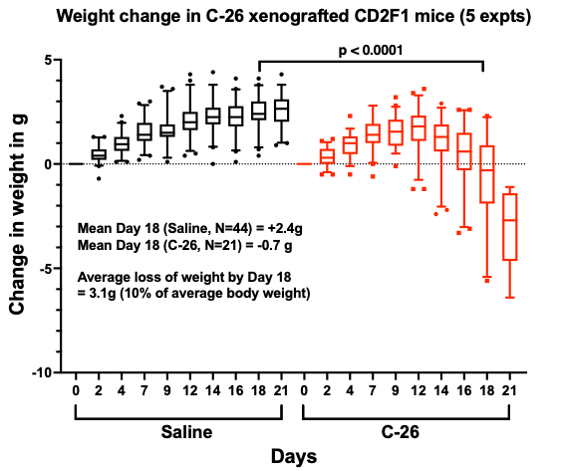
Dr. Steven Munger and Se-Jin Lee have agreed to share cachexia model. This model develops cachexia in males of CD2F1 (BALB/cJ female x DBA2J male) mice after being implanted with BALB/c mouse colorectal cancer cell line CT-26 (see figure). Female mice develop mild symptoms. Cachexia develops within a month of engraft and has a potential to ulcerate.

Obtaining CD2F1 male mice (BALB/cJ x DBA/2J)
- We purchase 10 DBA/2J males and 20 BALB/cJ mice from JAX. These mice will be bred in trios in BSL-1 facility (Annex 5). Expected number of pups are 5 pups per dame. We expect at least 50 male pups with this breeding. These mice will be mated once.
- The male mice will be aged to 8-12 weeks in Annex 5. Male mice may have to be single housed due to aggression.

Implanting and obtaining tumor models CT-26 cell line (BSL-1)
- We will implant the healthiest 40 mice with 10⁶ CT-26 cell line in 100uL subcutaneously. The cell line will be grown as per XLIS protocol.
- Ten mice will be injected with Saline instead of cells.
- We will house the mice for 2 weeks and deliver the mice
- During the two weeks we will measure weights and body condition score 3 times a week. We will also measure the size of the tumor before delivery.

Deliverables: (a) 50 male mice: 40 with CT-26 tumors and 10 with Saline (b) excel sheet with mouse IDs, weights, BCS and tumor size.

Estimated Cost: $13,180
Mice: 30 parental mice @ $40 per mouse = $1,200
Housing: $350 a section a week for ~ 16 weeks = $5,600
Mouse prep: 80 mice x $12 = $960
Project management labor: 6 hours @$100/hr = $600
Weights, BCS and tumor measurement 6 time points x $120 =$720
Tissue Culture labor: 6 hours @$100/hr =$600
Tissue Culture materials: $500
SubQ implant : 50 mice x $60 =$3,000

Please acknowledge

_____________________________________
Dr. Kumar

ACUC:
Lawson/Grant number:

Thank You,

_____________________
Muneer G. Hasham, Ph.D
Asc. Director XLIS

